Naan Mudhalvan Phase 4 Assessment

Course Name : Internet Of Things

Project Title : Public Transportation Optimization

Team Name : TechSpark

GitHub reference : <https://github.com/SANKARMAHARAJAN/Public-Transport-Optimization.git>

Team Members:

|  |  |  |
| --- | --- | --- |
| Name | Register number | Nan Mudhalvan ID |
| Praveen U.S | 721221106069 | au721221106069 |
| Sanjay S | 721221106088 | au721221106088 |
| Sankar Maharajan G | 721221106090 | au721221106090 |
| Murugesan | 72I221106303 | au2272120025 |

Introduction :

This project, titled "Public Transportation Optimization," aims to improve the efficiency and user experience of public transportation systems by developing a web-based platform with a user interface . The project leverages Internet of Things and web development technologies to create an interactive platform, this project will introduce some useful features. One of them is **Vehicle Tracking**, which lets you see where the buses are at any given moment. This real-time information will help you know exactly when your ride is coming, making your travel more convenient, **Route planning** is an additional feature, it helps to plan our journey efficiently and smoothly. To make things even more user-friendly, the project will include a section with **FAQs** (Frequently Asked Questions). This section will provide answers to common questions about using public transportation. It's like having a handy guide to help you understand how everything works and address any uncertainties you might have during your travels.

Project Objective:

* Develop a User-Friendly Web Interface: Create a user-friendly web interface to help commuters access information about public transportation schedules, routes, and other relevant details.
* Real-Time Updates: Implement real-time updates for tracking public transportation vehicles, reducing waiting times, and providing accurate information to commuters.
* User Feedback Mechanism: Integrate a feedback mechanism that allows users to provide input and report issues, enabling continuous improvement.

Technology Stack:

* Frontend:

HTML, CSS, JavaScript for building the user interface.

React Framework for a dynamic and responsive interface.

* Backend:

Django Framework

Python, a server-side language for handling user requests and data processing.

RESTful API for data communication between the frontend and backend.

MYSQL database system for database management.

Webpage Features:

1. Login and Registration Pages User Registration:

New users can create accounts by providing their email, username, password, and other necessary information.

User Authentication: Existing users can log in securely using their credentials.

Password Reset: Password reset functionality for users who forget their passwords.

1. Home Page Live Vehicle Tracking:

Real-time tracking of public transportation vehicles, allowing commuters to check the current location and estimated arrival times.

Route Planning: An interactive map with route planning options, enabling users to find the best routes based on their preferences.

News and Events: A section displaying the latest news and events related to public transportation, keeping users informed about service updates.

Frequently Asked Questions (FAQs): A comprehensive list of frequently asked questions and answers to address common user queries.

Webpage Images (Frontend works ):



This is the Login screen of our webpage; the login page serves as the entry point for registered users. It allows users to access their accounts by entering their login credentials.

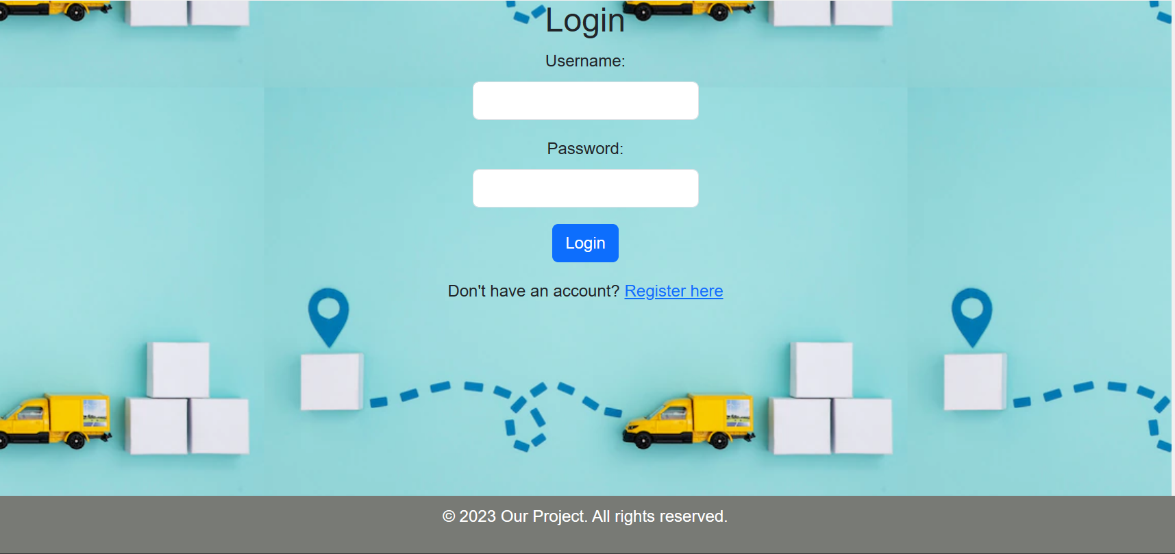

The home page is the central hub of the platform, providing various features and information like Track Location , Route Planning , News and Events and FAQs

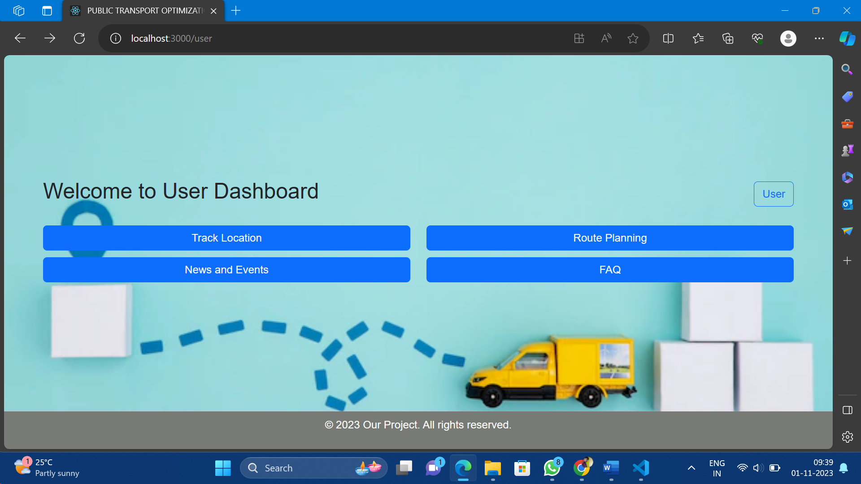

The "Track Location" page is dedicated to providing users with real-time tracking information of public transportation vehicles. Its primary purpose is to assist commuters in monitoring the current positions of vehicles and estimating their **arrival times**. The page may display estimated arrival times for each vehicle at selected stops.It displays the current Humidity and Temperature near the Vehicle , It helps users to carry umbrella , water bottles during summer and winter times.

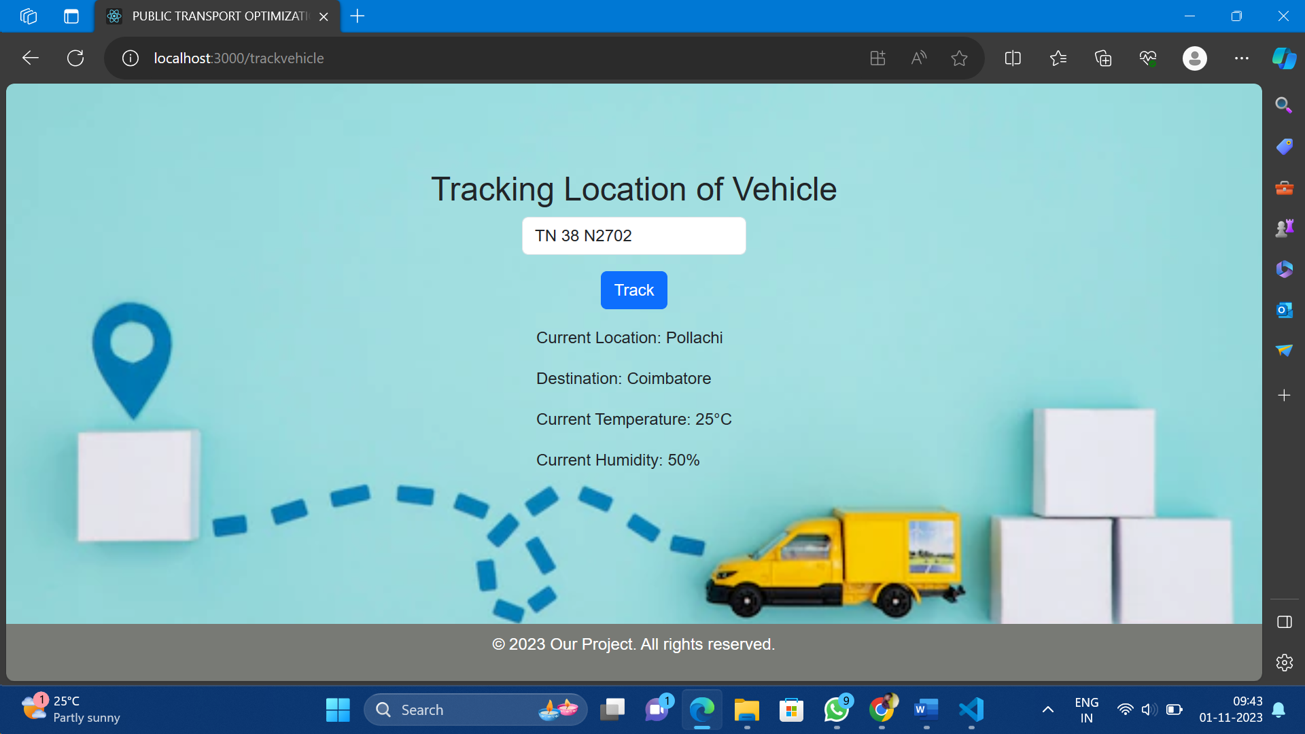

Working of Backend :

* Database Management System (DBMS):

Purpose: The DBMS, such as MySQL , is responsible for storing and managing the data used by the platform. It ensures data integrity, security, and efficient retrieval. Data Categories: The database stores user account information, real-time vehicle tracking data, route information, news and events data, FAQs, and user feedback.

* API (Application Programming Interface):

Purpose: The API defines endpoints and protocols for communication between the frontend and the backend. It serves as a bridge, allowing the frontend to request and receive data.

User Authentication: The API handles user authentication, ensuring secure login and registration processes.

Data Retrieval: It provides data retrieval endpoints for real-time vehicle tracking, route planning, news and events updates, FAQs, and user feedback.

* Server:

Purpose: The server serves as the core component of the backend, handling incoming user requests, processing data, and orchestrating communication between various parts of the system.

Conclusion:

The "Public Transportation Optimization " project aims to provide a comprehensive solution for optimizing public transportation services. With user-friendly login and registration pages, live vehicle tracking, route planning, news and events updates, FAQs, and a user feedback mechanism, this platform aims to enhance the commuting experience for the public while empowering transportation authorities with valuable insights. This report outlines the project's core features, technical implementation details, and the roadmap for its successful execution. The project's successful completion can significantly improve the public transportation system by providing real-time information and interaction for both commuters and authorities.